

**DEPARTMENT OF COMPUTER SCIENCE AND ENGINEERING**

**AUTUMN-2024**

**Project Report**

**Course Code:** CSE-4742

**Course Title:** Computer Graphics Lab

**Project Name:** Fish Aquarium

**SUBMITTED BY:**

|  |  |
| --- | --- |
| **ID** | **Name** |
| C213228 | Tahiyatut Tasnima |
| C213232 | Jannatul Ferdous Maisha |

**SUBMITTED TO:**

[Ashifatul Ferdousi](https://www.iiuc.ac.bd/profile/view/2687)

Assistant Lecturer

Computer Science and Engineering,IIUC

## **(a) Introduction**

* **Objective:** Our Fish Aquarium project created using the graphics.h library focuses on animating four fish, each designed with unique multicolor patterns that simulate natural swimming movements. The aquarium also includes an oxygen tank that randomly generates bubbles, adding realism to the underwater environment. The aquarium is visually enhanced with a decorative roof, stones, and moving grass, creating a captivating and aesthetically appealing underwater scene.
* **Background:** The program for a fish aquarium includes the graphics.h library for graphics functions and the bits/stdc++.h library for additional standard utilities. In the main() function, initgraph() shown initializes the graphical window. One of the most interesting features of the program is its ability to generate random bubbles through the random_bubbles function, which makes bubbles occur around the oxygen tank at random intervals and locations. The function uses the rand() function for bubble x and y coordinates, and these bubbles rise upwards in each frame by decreasing their y coordinate ;this can be said to be an emulation of natural motion.

The swimming of four types of fish will be displayed based on sinusoidal and cosine functions, thus rendering them swimming smoothly as experienced in nature. Fish 1 (sinusoidal_fish1) swims sinusoidally with respect to vertical motion from right to left using the sin() function. Fish 2 (sinusoidal_fish2) swims from left to right to the right that is being affected sinusoidally with respect to cosine function (cos()). Fish 3 (sinusoidal_fish3) swims from right to left likewise but with a smaller vertical sinusoidal perturbation. Finally, Fish 4 (sinusoidal_fish4), also swims left to right with a vertical sinusoidal motion with an upward constant shift to lower its position in the swimming pool that can be absorbed in a very smooth manner. Each fish was given highly unique designs along with multicolor in body, tail, and colorful eye designs which enhance diversity.

The draw_tank() function designs the aquarium, in which static are represented such as the built roof and sides. Some decorative stones have been added on the bottom using an ellipse() and circle() function. The grass growing onscreen in the fish tank at disparate heights, using a loop and by employing the function rand(), would give a habitat for the fishes close to underwater plants swaying gently.

## **(b)Literature Review**

## **Key Studies:** In some previous works, only two fish were animated, moving in simple linear paths across the screen. These fish didn’t exhibit the more natural sinusoidal motion that is often seen in real-life swimming, and the overall design was fairly minimalistic. There were also no moving plants or grass, and the fish were often displayed in a single color, making the scene appear flat and lifeless. In these older projects, the tank itself had a very simple structure, with no detailed elements like a roof design or decorative features. Overall, these earlier projects served as the foundation but lacked the complexity and realism that can make a simulation feel more alive.

## **Research Gap:** While previous aquarium simulation studies laid the groundwork, there were several key aspects that were missing. One major gap was the lack of realistic fish movement. The fish often followed simple horizontal paths, without any up-and-down sinusoidal motion that makes swimming look more natural. Another gap was the visual design of the fish themselves most previous projects only used basic, single-colored fish, which did not capture the vibrancy seen in real aquariums. Additionally, past works didn’t include other dynamic features, such as grass or plants swaying with the movement of the water, or bubbles rising from an oxygen tank. The tanks were also quite basic, with little to no decorative details like lines or borders that could give the tank a more structured and detailed look.

## **Relevance:** This report highlights the importance of improving the realism and engagement of aquarium simulations. By incorporating sinusoidal movement for the fish, multicolor fish designs, and adding dynamic features like moving grass and rising bubbles, this project takes the previous concepts to the next level. The introduction of a more detailed tank design with a structured roof and borders adds further complexity and visual interest. These enhancements help create a more immersive and visually appealing aquarium simulation. This project not only fills the gaps left by earlier works but also offers a more engaging platform for anyone interested in graphical animation techniques and creating realistic, interactive digital environments.

## 

## **(c) Methodology**

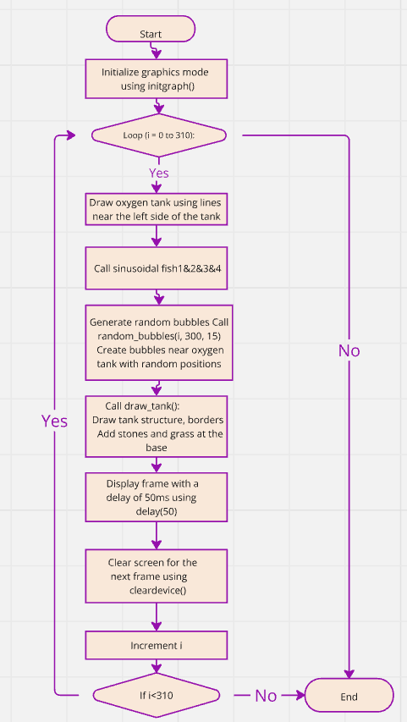

## Fig:Flow chart of fish Aquarium

## **(d) Results & Discussion**

* 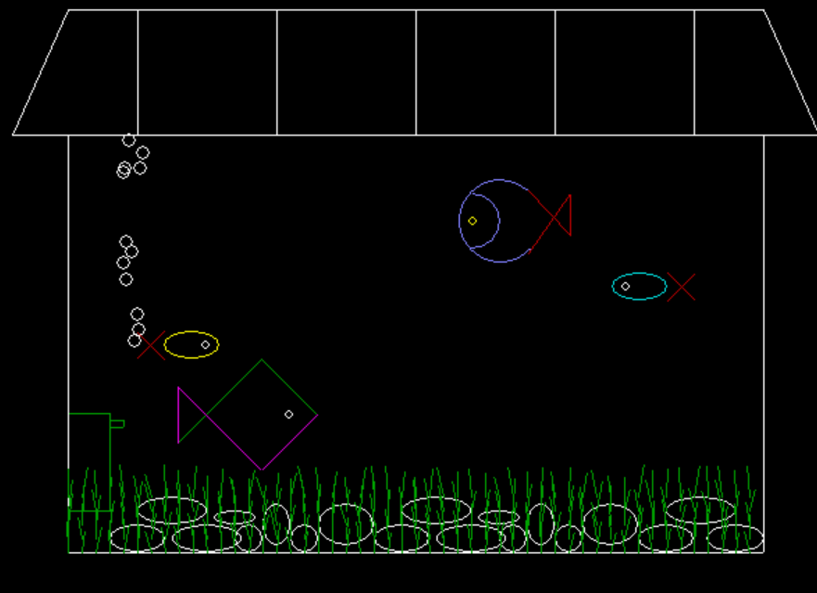**Results:**

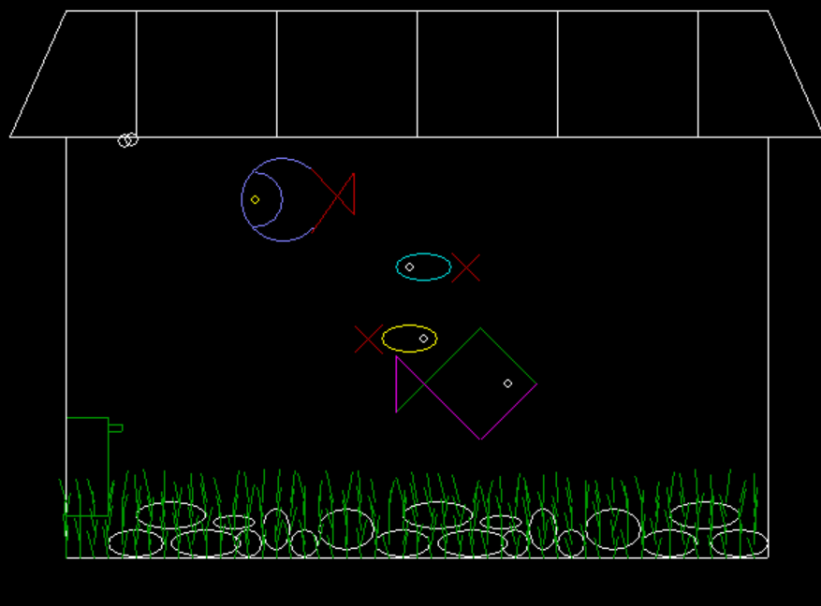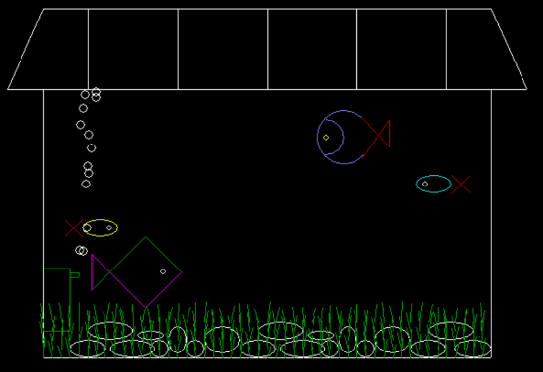 Fig 1: Start Fig 2: Fish,Bubble&Grass moving

## 

## 

Fig 3 : Position Change of 4 Fish Fig 4 : END

* **Discussion:** The output of the project displays four moving fish, each creating a realistic swimming effect through smooth sinusoidal motion. The fish are multicolored, which adds visual variety and enhances the overall aesthetics of the simulation. Additionally, the scene features moving underwater grass that sway, simulating natural movement in an aquatic environment. Random bubbles rise from the oxygen tank, further contributing to the realistic underwater atmosphere. The overall effect is a lively and visually engaging aquarium simulation with dynamic elements that make the environment feel more natural and immersive.

## **(e) Conclusion**

* **Summary:** The project successfully created an interactive and visually appealing aquarium simulation, featuring four multicolored fish that move realistically using sinusoidal motion. The aquarium also includes dynamic elements such as moving underwater grass and random bubbles rising from an oxygen tank. The use of the graphics.h library and graphical techniques added depth and realism to the simulation, resulting in a lively and engaging visual representation of an underwater environment**.**
* **Limitations:** Some challenges were faced during the fish color filling, especially with the tail movement. Additionally, implementing multi-colored bubbles was a challenge, requiring some adjustments to achieve a more realistic effect.
* **Recommendations:** Future improvements could focus on enhancing the fish colors by utilizing techniques like boundary fill and flood fill. Moreover, adding different fish shapes and water wave effects would improve the simulation's realism and variety.